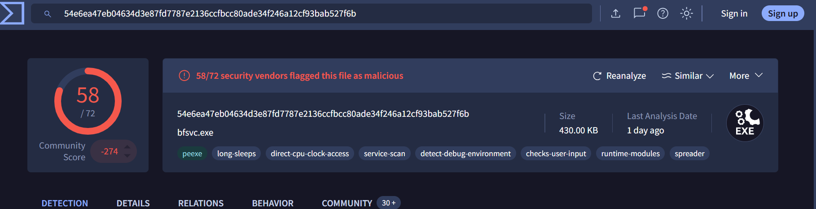
MALICIOUS ASSESSMENT
The file is malicious.
Fifty eight out of seventy two security vendors marked it as malicious.
The community score is heavily negative.
Static analysis shows multiple suspicious properties, including debug checks and persistence behavior.
Sandbox reports confirm actions linked to real malware, including long sleep delays, credential access behavior, crypto operations, and creation of new executable files.
The file shows consistent malicious indicators across all analysis sections.
--
INDICATORS OF COMPROMISE
Hash value
MD5 hash 287d612e29b71c90aa54947313810a25.
This is a secondary hash linked to the same malware sample in the Details tab.
IP address
104.16.249.249.
This IP address appears in the Relations tab under contacted hosts.
It has detection counts from multiple vendors.
Domain name
org.misecure.com.
This domaiin appears in the Relations tab with several detections.
It is tied to outbound connections during sandbox execution.
Network or host artifact
The malware created unauthorized executable files on execution.
Sandbox results list one new PE executable and hundreds of additional dropped files.
This confirms host level modification and post execution activity.
Tools
The malware used environment checks and process injection.
These actions help the file avoid detection and control system processes.
Tactics, techniques, and procedures
T1059 command execution.
T1055 process injection.
T1082 system information discovery.
T1105 external network communication.
T1027 obfuscation.,
These techniques match observed actions inside the sandbox and link the sample to known threat behavior.